UNIVERSITY ACADAMIC MANAGEMENT SYSTEM
A DBMS Capstone Project Report submitted in partial fulfillment of the requirements for the award of the degree of
BACHELOR OF TECHNOLOGY
in
ARTIFICIAL INTELLIGENCE AND MACHINE LEARNING

Submitted By

CH SASANK PAVAN TEJA – 25B11AI171
B REVANTH-25B11AI167
R SARSWATHI SAMEERA – 25B11AIA07
N. YASWANTHI-25B11AI816

Under the esteemed guidance of
Mr. T.Srinivasulu M.Tech, (Ph.D.)

Assistant Professor


DEPARTMENT OF ARTIFICIAL INTELLIGENCE AND MACHINE LEARNING

ADITYA UNIVERSITY
(Formerly Aditya Engineering College (A))
Aditya Nagar, ADB Road, Surampalem, Andhra Pradesh, India
2026 – 2027


Aditya Nagar, ADB Road, Surampalem, Andhra Pradesh, India
DEPARTMENT OF ARTIFICIAL INTELLIGENCE AND MACHINE LEARNING

CERTIFICATE

This is to certify that the DBMS Capstone Project report entitled “UNIVERSITY ACADAMIC MANAGEMENT SYSTEM” is being submitted by B.REVANTH (Roll No. 25B11AI167),CH.SASANK (Roll No.25B11AI171) ,R.SAMEERA (Roll No.25B11A07) and N.YASWANTHI(Roll No. 25B11AI816) in partial fulfillment of the requirements for the award of the B.Tech. degree in Artificial Intelligence and Machine Learning. The work documented in this report was carried out as part of the Capstone Project for the course Database Management Systems (2501IT05) during the academic year 2026–2027, and records the database design, implementation, and documentation undertaken by the team.

Project Guide Head of the Department
Mr. T. Srinivasulu, M. Tech, (Ph.D.) Dr. K. Naga Bhargavi, M. Tech, Ph.D.
Associate professor Associate Professor & HOD

External Examiner

DECLARATION
We hereby declare that the DBMS Capstone Project entitled “____________________________________________” is a genuine work carried out by us. The database design, SQL implementation, queries and documentation presented in this report are our own work, completed under the guidance of ____________________, Department of ____________________, Aditya University, Surampalem. We further declare that this work has not been submitted, in full or in part, for the award of any degree of this or any other educational institution.

Project Associates
____________________ (____________)
____________________ (____________)
____________________ (____________)
____________________ (____________)

Date: ____________
Place: Surampalem

ACKNOWLEDGEMENT

It is with immense pleasure that we express our indebted gratitude to our project guide
, Department of , who guided us throughout the capstone project. We are thankful for the constant encouragement and valuable suggestions received at every review stage.
We are grateful to , Head of the Department, for inspiring us and for arranging the facilities and resources needed for this project.
We extend our sincere thanks to the Management, Dr. M. Sreenivasa Reddy, Deputy Pro-Chancellor, Dr. M. B. Srinivas, Vice-Chancellor, and Dr. A. Ramesh, Pro Vice-Chancellor (Engineering & Sciences), for providing an excellent academic environment.
Not to forget, we thank the Teaching and Non-Teaching Staff, our parents and our friends, who have directly or indirectly supported us in completing this project on time.

Project Associates
Student Name Regd. No.
Student Name Regd. No.
Student Name Regd. No.
Student Name Regd. No.

ABSTRACT

The University Academic Management Database Application is designed to automate and manage academic activities within a university through a centralized relational database. The system stores and manages information related to students, departments, faculty, courses, enrolments, and examination results. The database minimizes redundancy, maintains data integrity through primary and foreign keys, and supports efficient retrieval of academic information using SQL queries. The design is normalized up to Third Normal Form (3NF), helping reduce update anomalies and improve consistency. The proposed system provides a structured foundation for student management, faculty management, course management, enrollment processing, result management, and academic reporting.

LIST OF FIGURES
Figure 1. ER Diagram of University Academic Management Database Figure 2. Proposed Three-Layer Database Application Architecture Figure 3. Student Management Screen
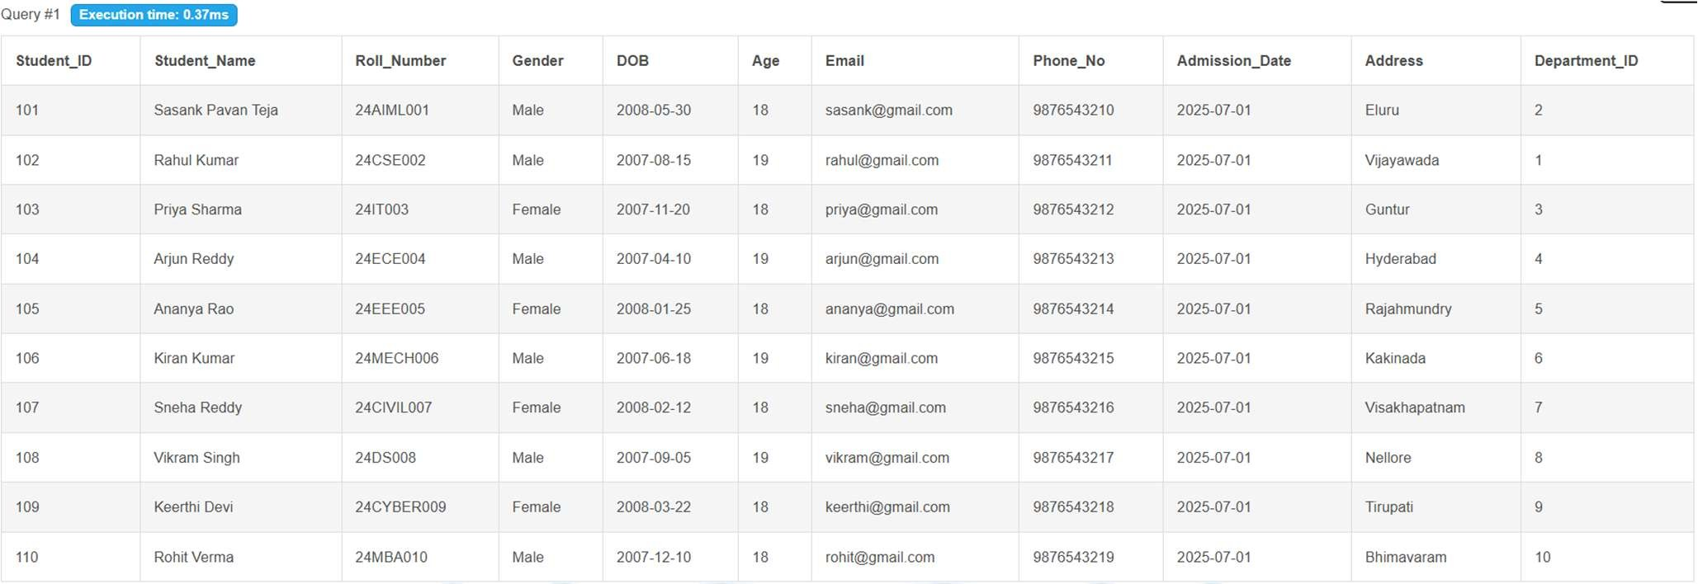
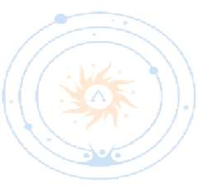
Figure 4. Course Management Screen
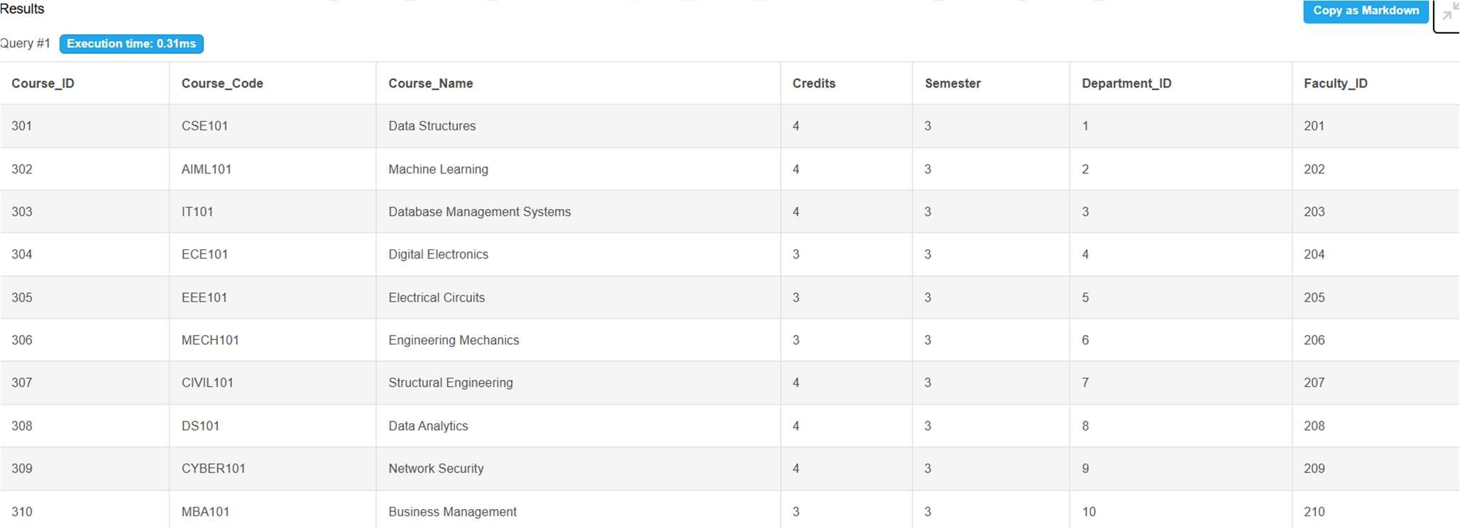
Figure 5. Enrollment / Result Screen

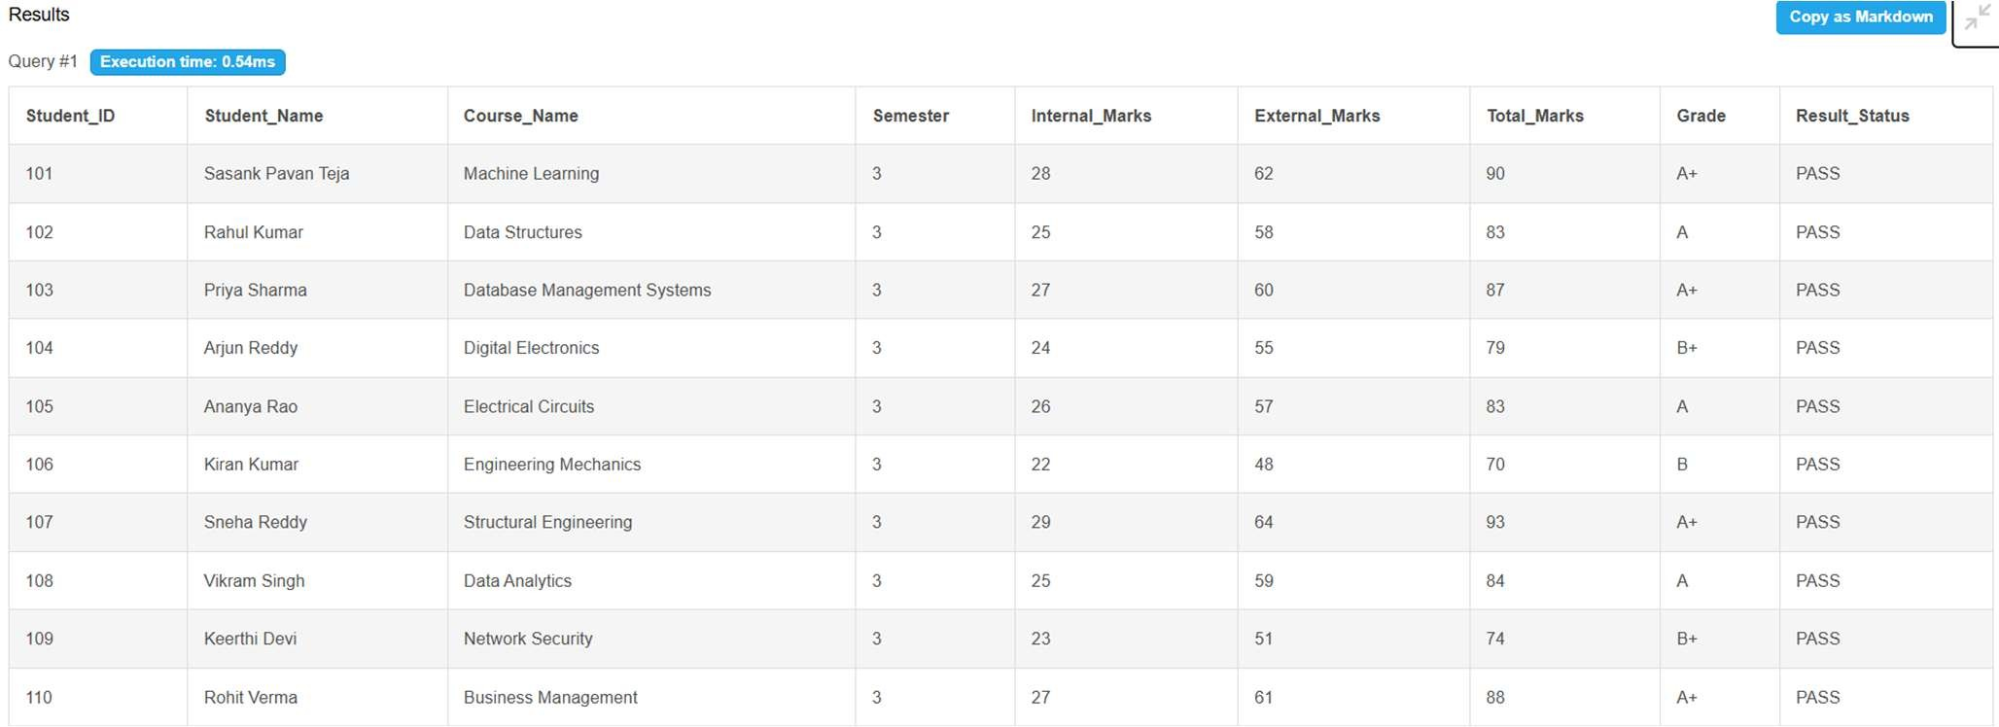
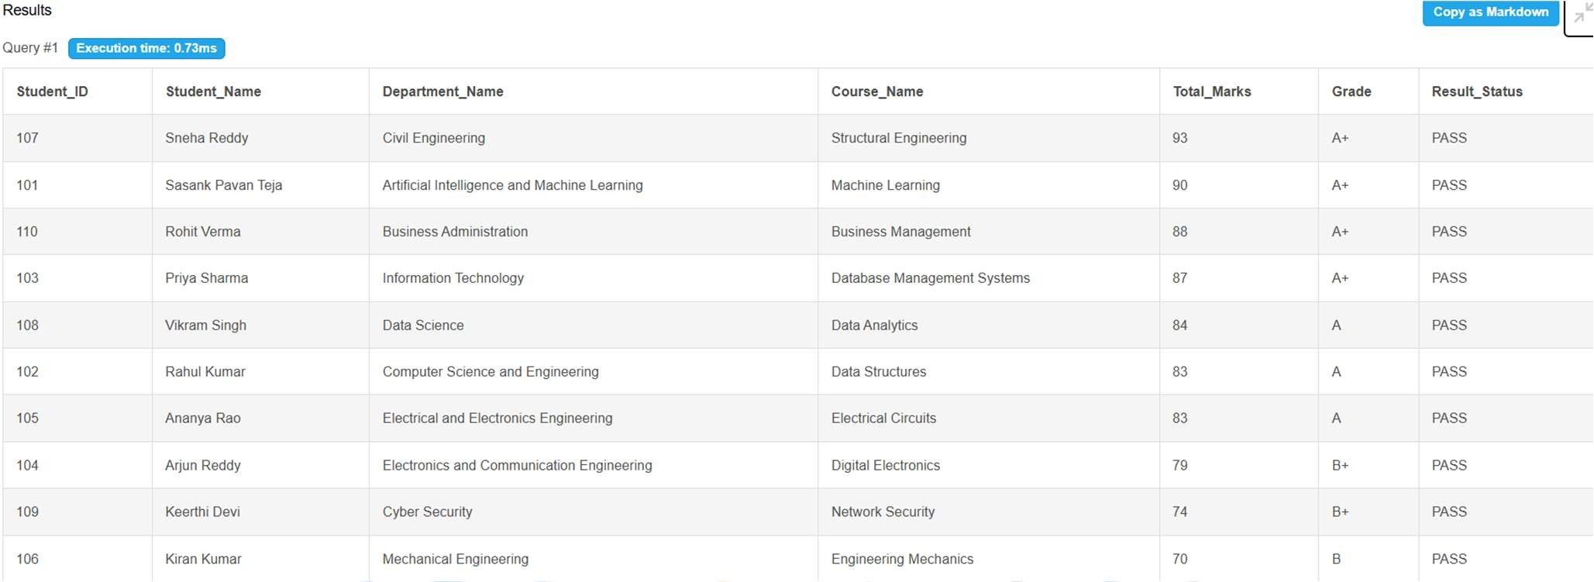
Figure 6. Report Generation Screen

LIST OF TABLES

Table 1. Major Database Entities Table 2. Department Table Structure Table 3. Student Table Structure Table 4. Faculty Table Structure Table 5. Course Table Structure Table 6. Enrollment Table Structure Table 7. Result Table Structure Table 8. Keys and Constraints
Table 9. Sample Data Records

ACRONYMS
- DBMS – Database Management System
- ER – Entity Relationship
- SQL – Structured Query Language
- DDL – Data Definition Language
- DML – Data Manipulation Language
- DQL – Data Query Language
- DCL – Data Control Language
- TCL – Transaction Control Language
- PK – Primary Key
- FK – Foreign Key
- 1NF – First Normal Form
- 2NF – Second Normal Form
- 3NF – Third Normal Form

INTRODUCTION

Brief Information about the Project
A University Academic Management System is a database application that manages academic information and administrative processes. The project provides a centralized relational database for departments, students, faculty, courses, enrollments, and examination results. It is intended to replace fragmented manual records and multiple spreadsheet files with a structured database that supports consistent storage and efficient retrieval.

Motivation and Contribution of Project
The project is motivated by common problems in academic record management such as duplicate records, time-consuming searches, inconsistent information, and difficulty in generating reports. A centralized database provides a systematic approach to storing related academic data and enforcing relationships through keys and constraints.
      - Centralizing academic records in one relational database.
      - Reducing duplicate and inconsistent information.
      - Maintaining referential integrity using primary and foreign keys.
      - Supporting faster academic queries and report generation.
      - Providing a foundation for student, faculty, course, enrollment, and result management.

Objectives of the Project
      - Develop a centralized academic database.
      - Manage student records.
      - Maintain faculty information.
      - Store department details.
      - Handle course registration and student enrollments.
      - Record examination results.
      - Reduce duplicate data and update anomalies.
      - Maintain referential integrity.
      - Support efficient SQL queries and academic reports.

Scope of the Project
The scope covers database-oriented management of university academic information. The core scope includes department, student, faculty, course, enrollment, and result data. The database can be used as the backend for an administrative application and can be extended later with attendance, fee, timetable, library, examination scheduling, and web/mobile interfaces.

SYSTEM ANALYSIS

Existing System
      - Manual record maintenance.
      - Multiple Excel sheets or disconnected files.
      - Duplicate records and inconsistent information.
      - Time-consuming searches.
      - Difficulty in generating consolidated reports.
      - Higher possibility of data-entry errors.

Proposed System
The proposed system uses a centralized relational database. It organizes academic information into related tables and uses primary keys, foreign keys, uniqueness rules, NOT NULL conditions, and CHECK constraints where appropriate. The system supports student, faculty, department, course, enrollment, and result management.
      - Centralized database
      - Student management
      - Faculty management
      - Course management
      - Enrollment management
      - Result processing
      - SQL-based reporting
      - Referential integrity

Functional Requirements
Module | Functional Requirement
Student Management | Add, update, search, and display student details.
Department Management | Store and maintain department information.
Faculty Management | Store faculty details and associate faculty with departments.
Course Management | Maintain courses, credits, departments, and faculty associations.
Enrollment Management | Register students for courses and maintain enrollment details.
Result Management | Store examination marks and grades associated with an enrollment.
Search and Reporting | Retrieve student, course, enrollment, and result information using SQL queries.

Non-Functional Requirements
      - Performance – queries should return results efficiently for normal academic workloads.
      - Integrity – invalid references and duplicate key values should be prevented.
      - Security – database privileges should be controlled for administrative users.
      - Usability – forms and reports should be understandable to users.
      - Reliability – transactions should preserve consistent database state.
      - Scalability – the design should support growth in students, courses, and academic records.

Requirements Specification
Category | Suggested Requirement
Hardware | Intel i3 or above; 4 GB RAM minimum; adequate storage; standard display and keyboard/mouse.
Operating System | Windows 10/11 or an equivalent supported platform.
Database | Oracle Database or another relational DBMS used by the implementation.

DATABASE DESIGN

Major Entities
Entity | Description
Department | Stores department information.
Student | Stores student records.
Faculty | Stores faculty details.
Course | Stores course information.
Enrollment | Represents student course registration.
Result | Stores examination result information linked to enrollment.

ER Model
The ER model represents the major entities and their relationships. The source documentation identifies Department–Student, Department–Faculty, Department–Course, Faculty–Course, Student–Enrollment, Course–Enrollment, and Enrollment–Result relationships. The diagram in the supplied project material also shows attributes such as Student_ID, Roll_No, Student_Name, Department_ID, Faculty_ID, Course_ID, Enrollment_ID, Result_ID, marks, grade, and related academic attributes.

Relationships
Relationship | Description
Department → Student | One department can have many students.
Department → Faculty | One department can have many faculty members.
Department → Course | One department can offer many courses.
Faculty → Course | Faculty members can be associated with courses.
Student → Enrollment | A student can have multiple enrollment records.
Course → Enrollment | A course can have multiple enrollment records.
Enrollment → Result | An enrollment can have an associated result record.

ER DIAGRAM
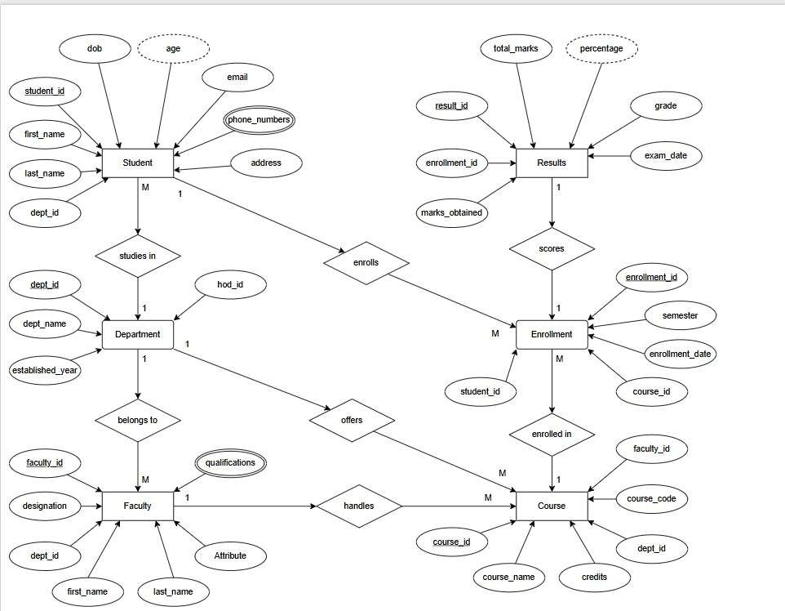

Figure 1: ER Diagram of University Academic Management Database
The ER diagram summarizes the entity structure and cardinalities described in the supplied DBMS project material. It is a documentation-level representation; the final project team should align attribute names and cardinalities with the actual implemented database.

RELATIONAL SCHEMA

Relation | Relational Schema
DEPARTMENT | Department_ID (PK), Department_Name, Department_Code, HOD_Name
STUDENT | Student_ID (PK), Student_Name, Roll_Number, Gender, DOB, Age, Email, Phone_No, Admission_Date, Address, Department_ID (FK)
FACULTY | Faculty_ID (PK), Faculty_Name, Qualification, Designation, Email, Phone_No, Join_Date,  Experience, Department_ID (FK)
COURSE | Course_ID (PK), Course_Code, Course_Name, Credits, Semester, Department_ID (FK), Faculty_ID (FK)
ENROLLMENT | Enrollment_ID (PK), Student_ID (FK), Course_ID (FK), Enrollment_Date, Academic_Year,  Semester
RESULT | Result_ID (PK), Enrollment_ID (FK), Internal_Marks, External_Marks, Total_Marks, Grade, Result_Status

The relational schema follows the structure presented in the supplied project material. The Student and Faculty relations reference Department; Course references Department and Faculty; Enrollment references Student and Course; and Result references Enrollment.
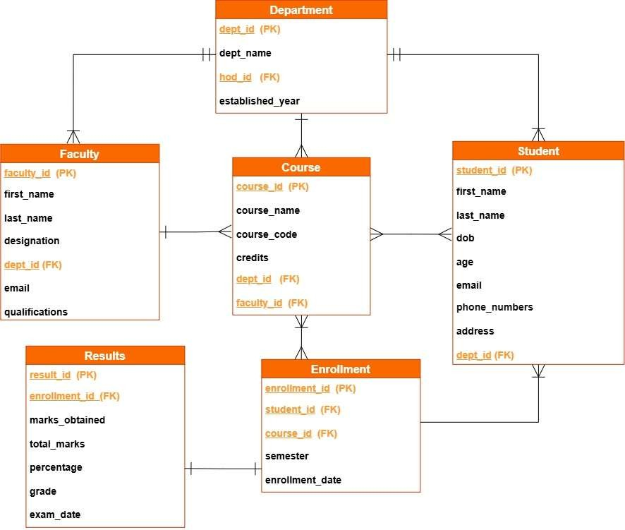

TABLE DESIGN

Department Table
Attribute | Data Type | Constraint | Description
Department_ID | INT / NUMBER | PK, NOT NULL | Unique department identifier
Department_Name | VARCHAR | NOT NULL | Department name
Department_Code | VARCHAR | UNIQUE | Department code
HOD_Name | VARCHAR | — | Head of Department name

Student Table
Attribute | Data Type | Constraint | Description
Student_ID | INT | PK | Unique student identifier
Student_Name | VARCHAR | NOT NULL | Student name
Roll_Number | VARCHAR | UNIQUE | Institution roll number
Gender | VARCHAR | — | Gender value as required by implementation
DOB | DATE | — | Date of birth
Age | INT | — | Age, if maintained
Email | VARCHAR | UNIQUE | Student email
Phone_No | VARCHAR | — | Contact number
Admission_Date | DATE | — | Admission date
Address | VARCHAR | — | Address
Department_ID | INT | FK | References Department

Faculty Table
Attribute | Data Type | Constraint | Description
Faculty_ID | INT | PK | Unique faculty identifier
Faculty_Name | VARCHAR | NOT NULL | Faculty name
Qualification | VARCHAR | — | Academic qualification
Designation | VARCHAR | — | Faculty designation
Email | VARCHAR | UNIQUE | Faculty email
Phone_No | VARCHAR | — | Contact number
Join_Date | DATE | — | Joining date
Experience | INT | — | Experience in years, if maintained
Department_ID | INT | FK | References Department

Course Table
Attribute | Data Type | Constraint | Description
Course_ID | INT | PK | Unique course identifier
Course_Code | VARCHAR | UNIQUE | Course code
Course_Name | VARCHAR | NOT NULL | Course name
Credits | INT | CHECK | Credit value
Semester | INT | — | Semester offered
Department_ID | INT | FK | References Department
Faculty_ID | INT | FK | References Faculty

Enrollment Table
Attribute | Data Type | Constraint | Description
Enrollment_ID | INT | PK | Unique enrollment identifier
Student_ID | INT | FK | References Student
Course_ID | INT | FK | References Course
Enrollment_Date | DATE | — | Enrollment date
Academic_Year | VARCHAR | — | Academic year
Semester | INT | — | Semester

Result Table
Attribute | Data Type | Constraint | Description
Result_ID | INT | PK | Unique result identifier
Enrollment_ID | INT | FK | References Enrollment
Internal_Marks | DECIMAL | — | Internal assessment marks
External_Marks | DECIMAL | — | External examination marks
Total_Marks | DECIMAL | — | Total marks
Grade | VARCHAR | — | Grade obtained
Result_Status | VARCHAR | — | Pass/fail or equivalent status

Keys and Constraints
Constraint Type | Applied To / Purpose
Primary Key | Department_ID, Student_ID, Faculty_ID, Course_ID, Enrollment_ID, Result_ID
Foreign Key | Student.Department_ID; Faculty.Department_ID; Course.Department_ID; Course.Faculty_ID; Enrollment.Student_ID; Enrollment.Course_ID;  Result.Enrollment_ID
NOT NULL | Required attributes such as names and identifiers
UNIQUE | Roll number, email, course code, and department code where applicable
CHECK | Values such as course credits and marks can be restricted to valid ranges
DEFAULT | Can be used for fields such as result status or semester when appropriate

NORMALIZATION
Normalization organizes data into related relations to reduce redundancy and update anomalies. The supplied project template explicitly requires documentation from UNF to 3NF. The following example uses an academic registration record to illustrate the process.

Unnormalized Form (UNF)
A single academic record might contain Student_ID, Student_Name, Department_Name, Course_ID, Course_Name, Faculty_Name, multiple course values, and multiple result values in one record. Repeating course groups and repeated department/faculty information create redundancy.

First Normal Form (1NF)
In 1NF, repeating groups are removed and each attribute contains atomic values. Each course enrollment is represented as a separate row. Student and department details may still be repeated across multiple enrollment records.

Second Normal Form (2NF)
In 2NF, partial dependencies on a composite key are removed. Student-specific attributes depend on Student_ID, course-specific attributes depend on Course_ID, and enrollment-specific attributes depend on Enrollment_ID. These dependencies motivate separate Student, Course, and Enrollment relations.

Third Normal Form (3NF)
In 3NF, transitive dependencies are removed. Department details are stored in Department rather than repeated in Student, Faculty, and Course. Faculty details are stored in Faculty rather than repeated in Course. Result details are linked to Enrollment through Result. The resulting structure supports the 3NF objective stated in the supplied project material.

Relation | Reason for Separation
Department | Stores department-specific attributes once.
Student | Stores student-specific attributes and a Department_ID reference.
Faculty | Stores faculty-specific attributes and a Department_ID  reference.
Course | Stores course-specific attributes and references its department/faculty.
Enrollment | Stores the student–course registration relationship.
Result | Stores marks/grade information for an enrollment.

SQL IMPLEMENTATION

DDL – Data Definition Language
The following DDL is a documentation-ready implementation aligned with the supplied relational schema. Data types may be adjusted to the specific DBMS used by the student team.
CREATE TABLE Department ( Department_ID NUMBER PRIMARY KEY,
Department_Name VARCHAR2(100) NOT NULL, Department_Code VARCHAR2(20) UNIQUE, HOD_Name VARCHAR2(100)
);

CREATE TABLE Student (
Student_ID NUMBER PRIMARY KEY,
Student_Name VARCHAR2(100) NOT NULL, Roll_Number VARCHAR2(30) UNIQUE, Gender VARCHAR2(20),
DOB DATE, Age NUMBER,
Email VARCHAR2(100) UNIQUE, Phone_No VARCHAR2(15),
Admission_Date DATE, Address VARCHAR2(200),
Department_ID NUMBER, CONSTRAINT fk_student_dept
FOREIGN KEY (Department_ID) REFERENCES Department(Department_ID)
);

CREATE TABLE Faculty (
Faculty_ID NUMBER PRIMARY KEY,
Faculty_Name VARCHAR2(100) NOT NULL, Qualification VARCHAR2(100), Designation VARCHAR2(50),
Email VARCHAR2(100) UNIQUE, Phone_No VARCHAR2(15),
Join_Date DATE, Experience NUMBER, Department_ID NUMBER,
CONSTRAINT fk_faculty_dept FOREIGN KEY (Department_ID)
REFERENCES Department(Department_ID)
);

CREATE TABLE Course (
Course_ID NUMBER PRIMARY KEY, Course_Code VARCHAR2(20) UNIQUE, Course_Name VARCHAR2(100) NOT NULL,
Credits NUMBER CHECK (Credits > 0), Semester NUMBER,
Department_ID NUMBER, Faculty_ID NUMBER, CONSTRAINT fk_course_dept

FOREIGN KEY (Department_ID) REFERENCES Department(Department_ID),
CONSTRAINT fk_course_faculty FOREIGN KEY (Faculty_ID) REFERENCES Faculty(Faculty_ID)
);

CREATE TABLE Enrollment ( Enrollment_ID NUMBER PRIMARY KEY, Student_ID NUMBER NOT NULL, Course_ID NUMBER NOT NULL,
Enrollment_Date DATE, Academic_Year VARCHAR2(20), Semester NUMBER,
CONSTRAINT fk_enroll_student
FOREIGN KEY (Student_ID) REFERENCES Student(Student_ID), CONSTRAINT fk_enroll_course
FOREIGN KEY (Course_ID) REFERENCES Course(Course_ID)
);

CREATE TABLE Result (
Result_ID NUMBER PRIMARY KEY,
Enrollment_ID NUMBER NOT NULL, Internal_Marks NUMBER, External_Marks NUMBER, Total_Marks NUMBER,
Grade VARCHAR2(5),
Result_Status VARCHAR2(20), CONSTRAINT fk_result_enrollment
FOREIGN KEY (Enrollment_ID) REFERENCES Enrollment(Enrollment_ID)
);

DML – Data Manipulation Language
INSERT INTO Department VALUES (1,'Information Technology','IT','Dr. Faculty Name');

INSERT INTO Student
(Student_ID, Student_Name, Roll_Number, Email, Department_ID) VALUES
(101,'Student One','IT01','student1@example.edu',1);

INSERT INTO Faculty
(Faculty_ID, Faculty_Name, Designation, Department_ID) VALUES
(201,'Faculty One','Assistant Professor',1);

INSERT INTO Course
(Course_ID, Course_Code, Course_Name, Credits, Semester, Department_ID, Faculty_ID) VALUES
(301,'23IT05','Database Management Systems',4,5,1,201);

INSERT INTO Enrollment
(Enrollment_ID, Student_ID, Course_ID, Enrollment_Date, Academic_Year, Semester)

VALUES
(401,101,301,SYSDATE,'2026-27',5);

INSERT INTO Result
(Result_ID, Enrollment_ID, Internal_Marks, External_Marks, Total_Marks, Grade, Result_Status)
VALUES (501,401,28,62,90,'A+','PASS');

DQL – Data Query Language
SELECT * FROM Student;

SELECT Student_ID, Student_Name, Email FROM Student
WHERE Department_ID = 1;

SELECT Course_ID, Course_Code, Course_Name, Credits FROM Course
ORDER BY Course_Name;

SELECT s.Student_Name, d.Department_Name FROM Student s
JOIN Department d ON s.Department_ID = d.Department_ID;

SELECT s.Student_Name, c.Course_Name, e.Academic_Year, e.Semester FROM Student s
JOIN Enrollment e ON s.Student_ID = e.Student_ID JOIN Course c ON e.Course_ID = c.Course_ID;

SQL QUERIES & SCREENSHOTS
The following query set is prepared to satisfy the documentation requirement for a 30–40 query SQL section. The examples cover selection, filtering, joins, aggregation, subqueries, updates, deletion, and reporting. Exact outputs depend on the records inserted in the final project database.
Q1. Display all departments
SELECT * FROM Department;

Output:
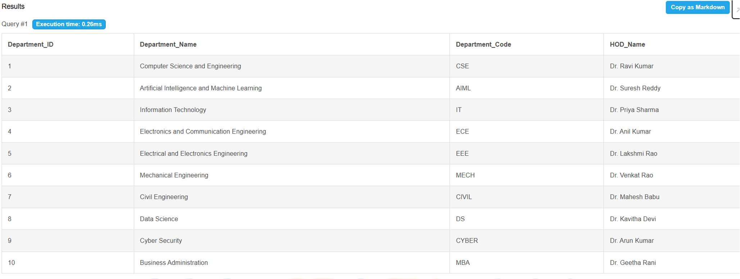

Q2. Display all students
SELECT * FROM Student;

Output:
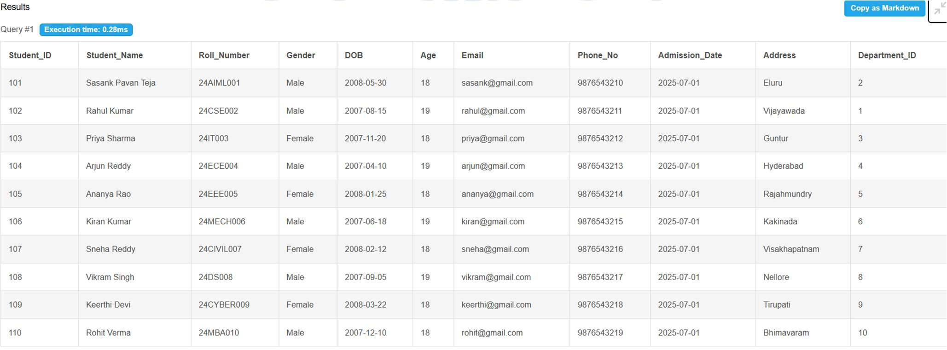

Q3. Display all faculty

SELECT * FROM Faculty;

Output:
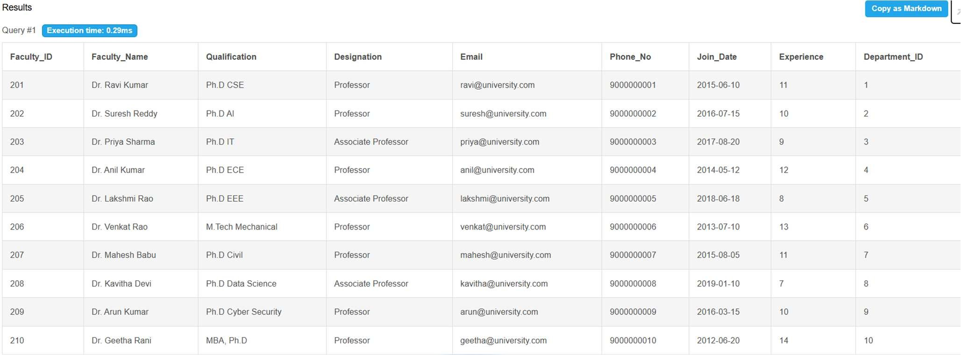

Q4. Display all courses
SELECT * FROM Course;

Output:
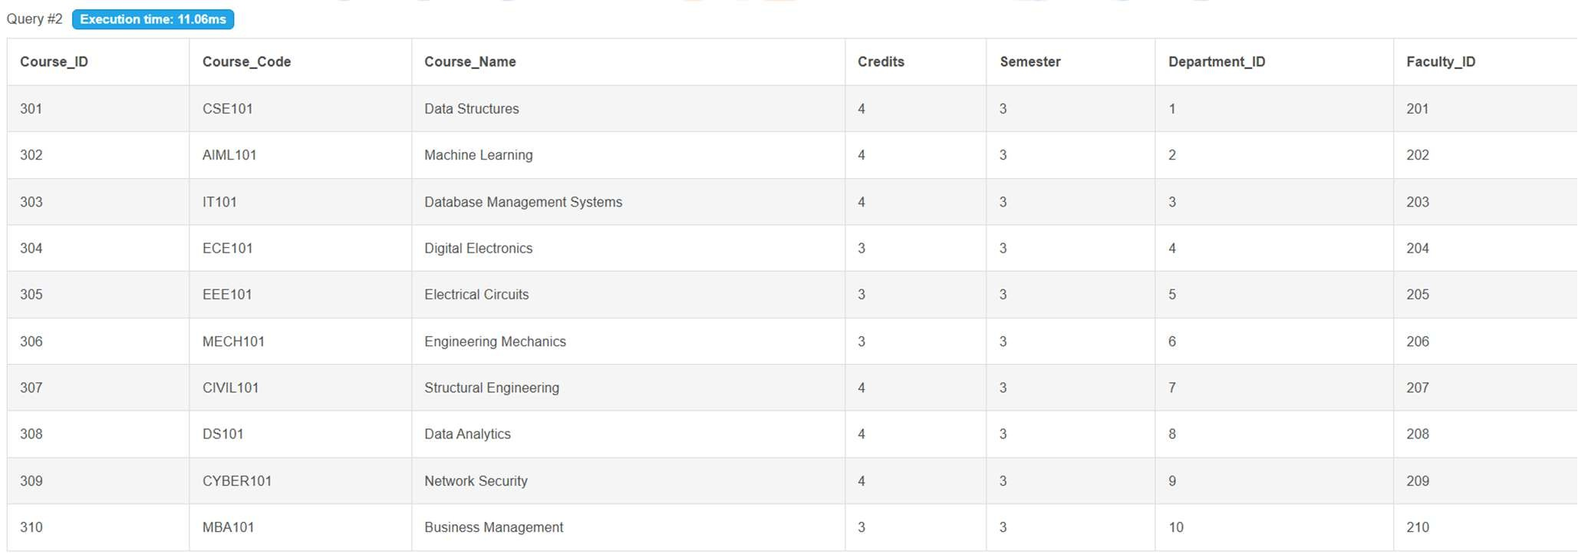

Q5. Students from a department
SELECT * FROM Student WHERE Department_ID = 1;

Output:
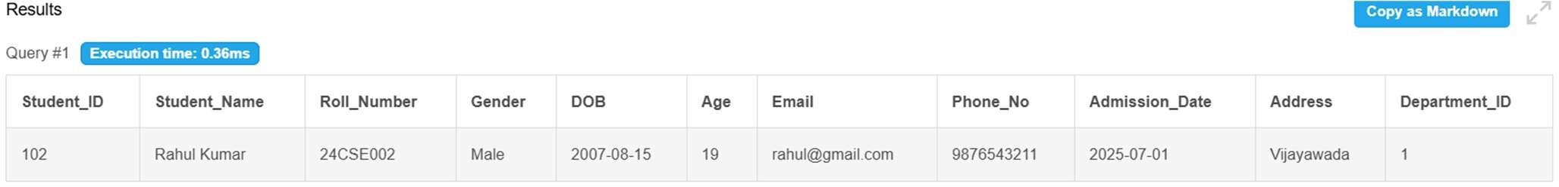

Q6. Courses with more than 3 credits
SELECT * FROM Course WHERE Credits > 3;

Output:
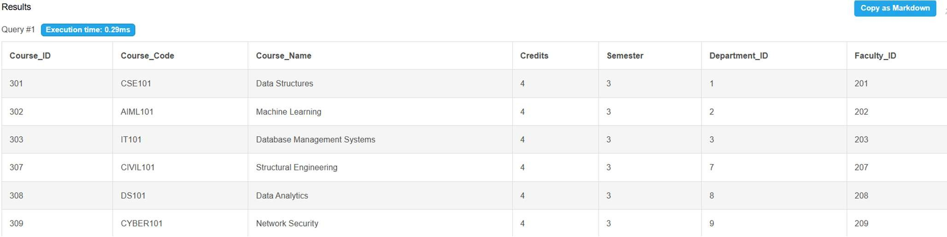

Q7. Students sorted by name
SELECT * FROM Student ORDER BY Student_Name;

Output:
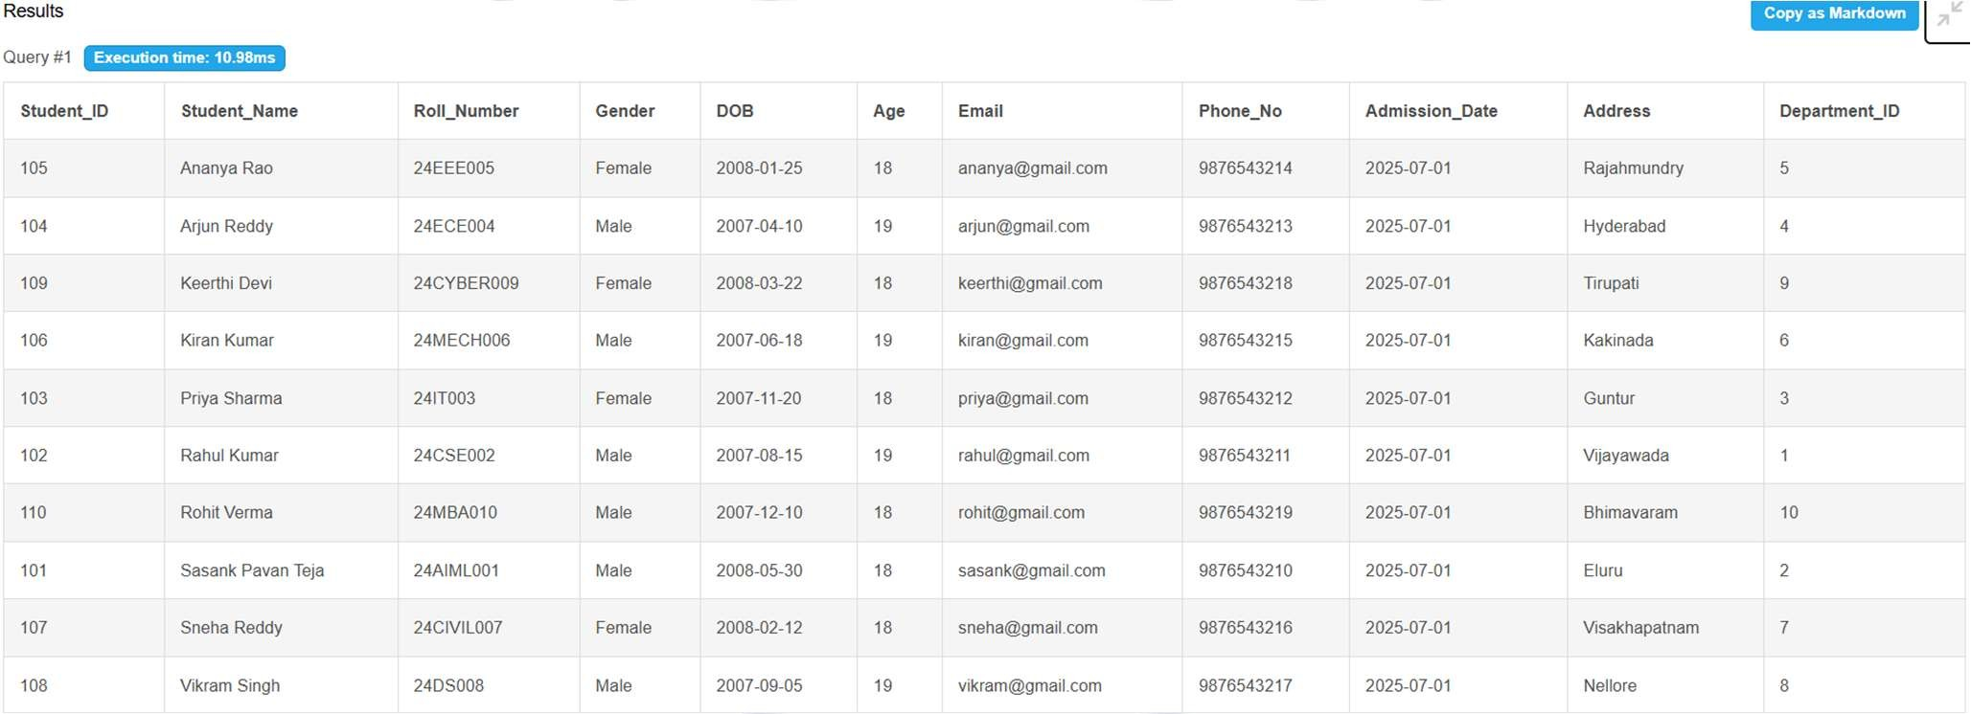

Q8. Courses sorted by credits
SELECT * FROM Course ORDER BY Credits DESC;

Output:

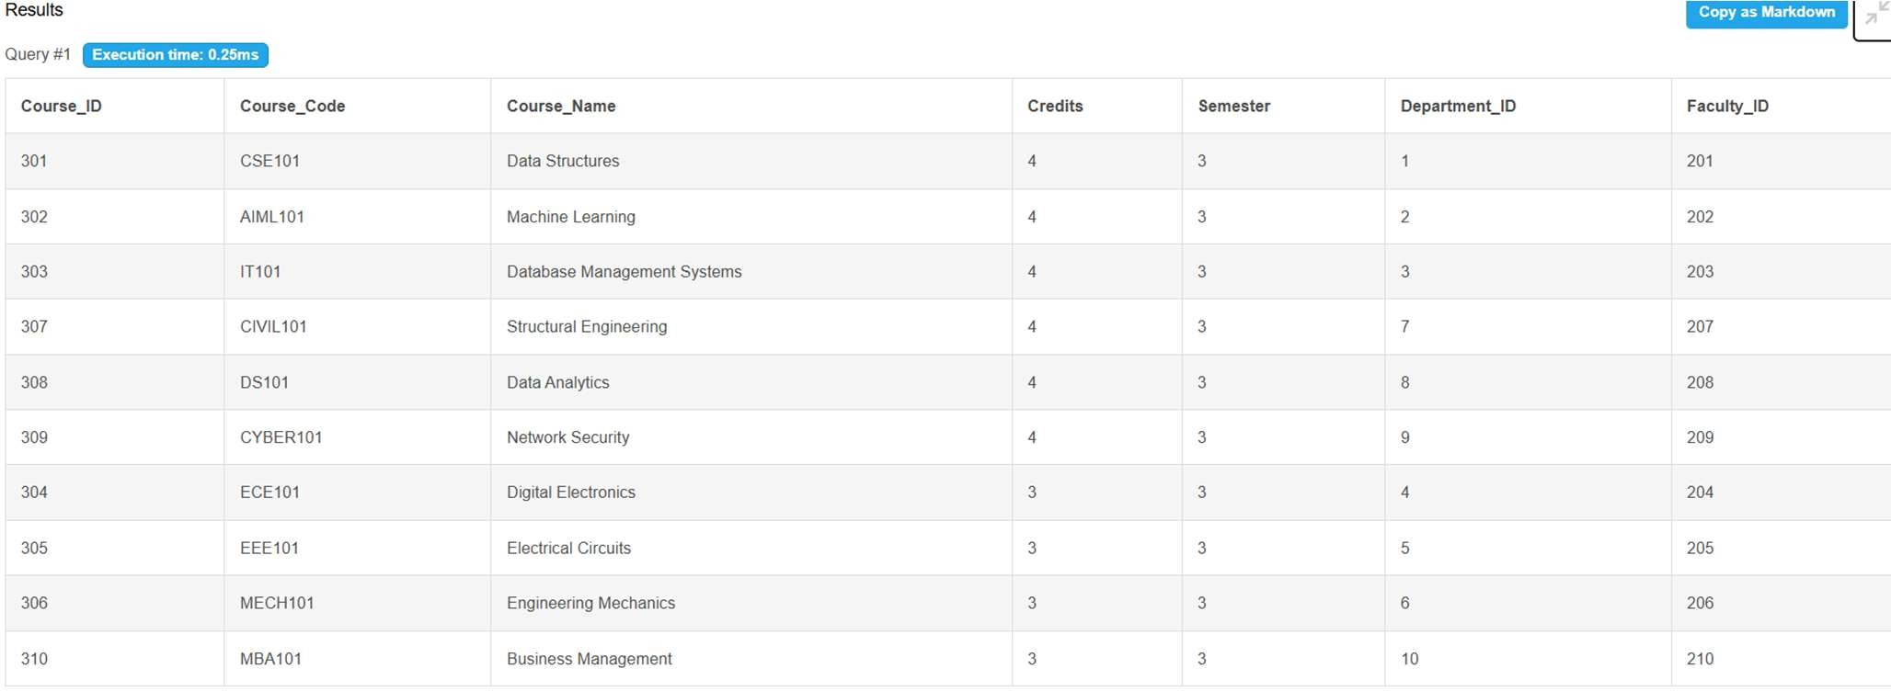

Q9. Students with email addresses
SELECT Student_ID, Student_Name, Email FROM Student WHERE Email IS NOT NULL;

Output:
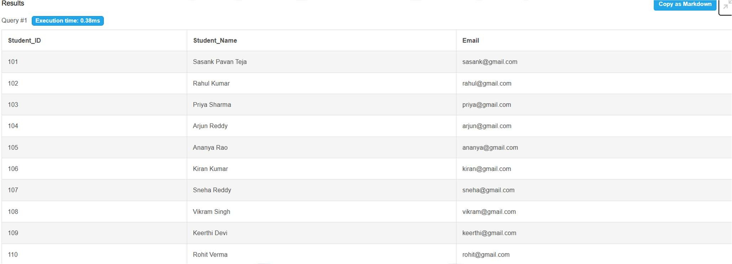

Q10. Department and students
SELECT d.Department_Name, s.Student_Name FROM Department d JOIN Student s ON d.Department_ID=s.Department_ID;

Output:

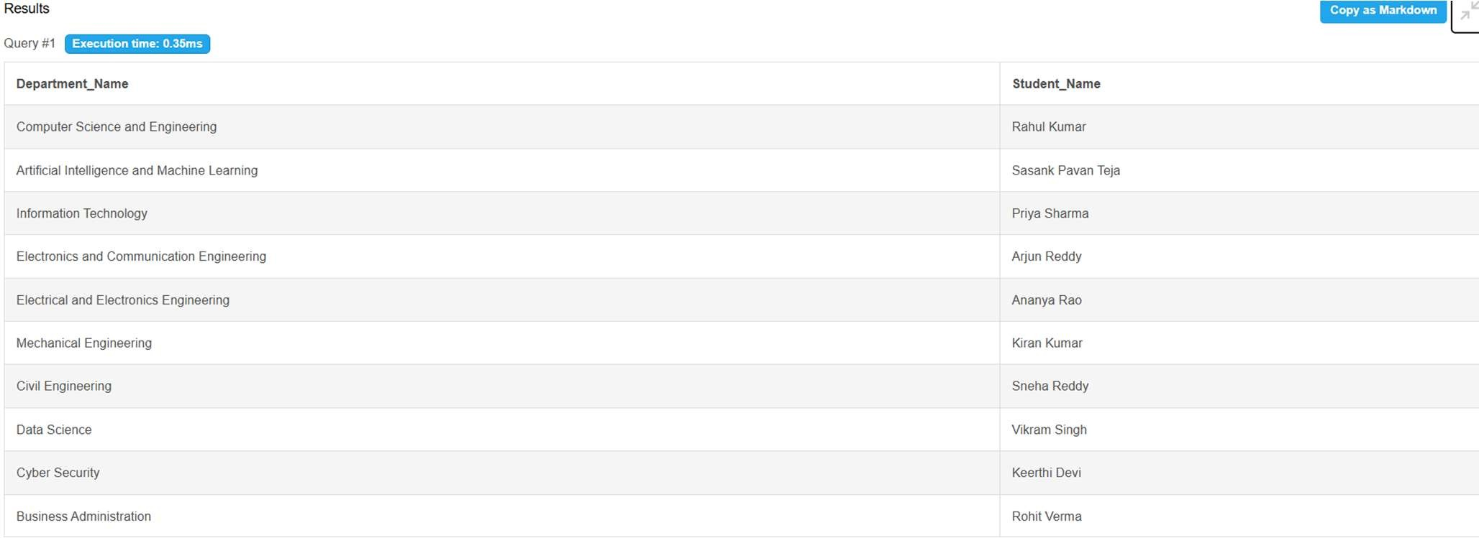

Q11. Faculty with department
SELECT f.Faculty_Name, d.Department_Name FROM Faculty f JOIN Department d ON f.Department_ID=d.Department_ID;

Output:
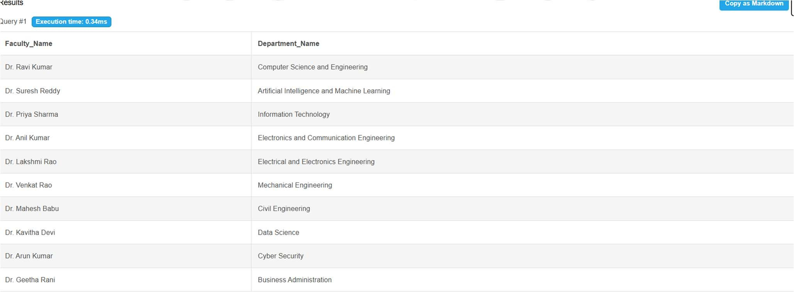

Q12. Courses with department
SELECT c.Course_Name, d.Department_Name FROM Course c JOIN Department d ON c.Department_ID=d.Department_ID;

Output:

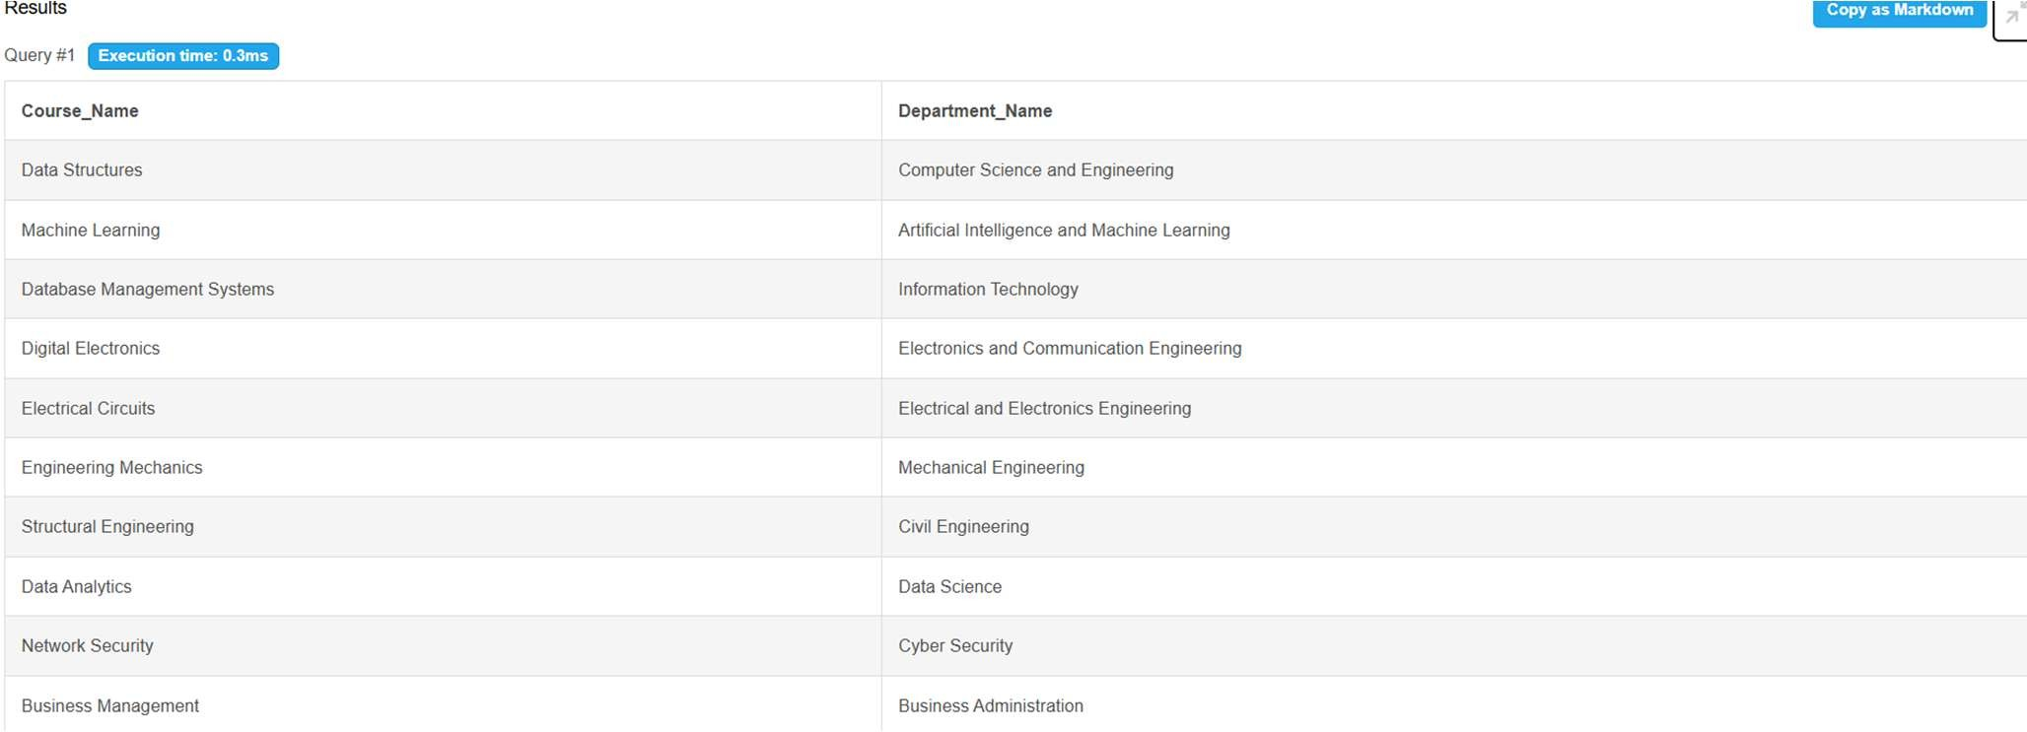

Q13. Courses with faculty
SELECT c.Course_Name, f.Faculty_Name FROM Course c JOIN Faculty f ON c.Faculty_ID=f.Faculty_ID;

Output:
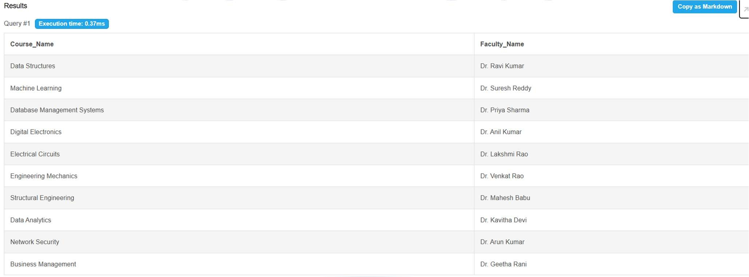
Q14. Enrollment details
SELECT e.Enrollment_ID, s.Student_Name, c.Course_Name FROM Enrollment e JOIN Student s ON e.Student_ID=s.Student_ID JOIN Course c ON e.Course_ID=c.Course_ID;

Output:

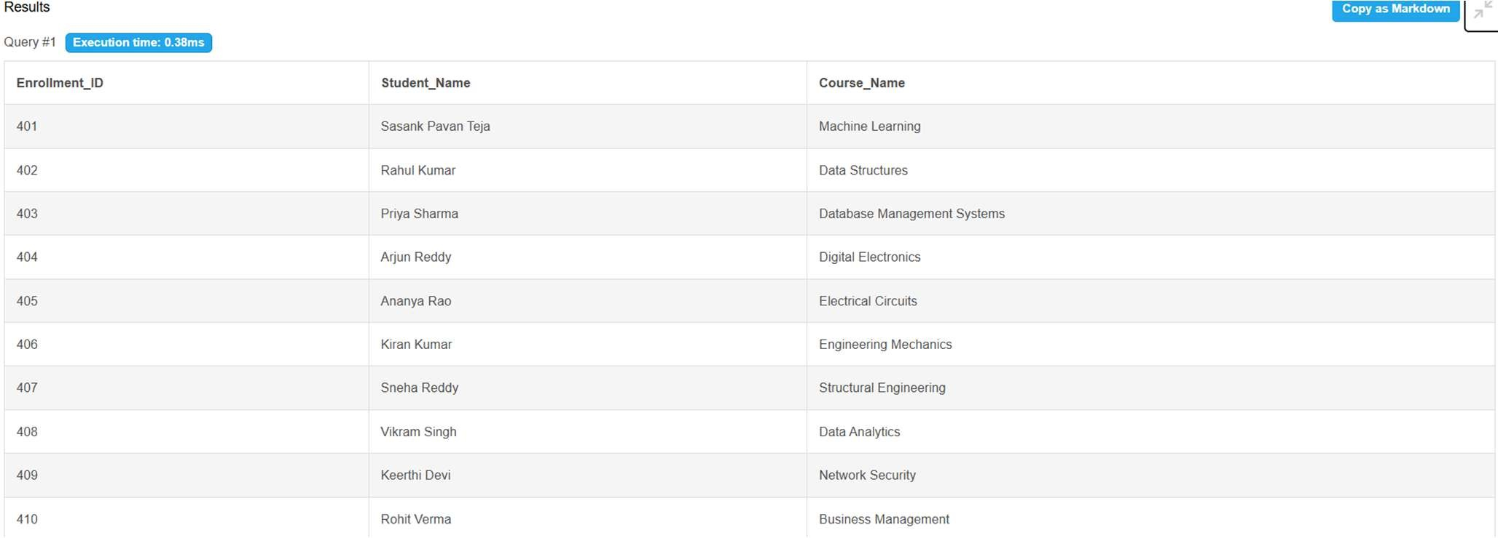

Q15. Student result details
SELECT s.Student_Name, c.Course_Name, r.Total_Marks, r.Grade FROM Result r JOIN Enrollment e ON r.Enrollment_ID=e.Enrollment_ID JOIN Student s ON e.Student_ID=s.Student_ID JOIN Course c ON e.Course_ID=c.Course_ID;

Output:
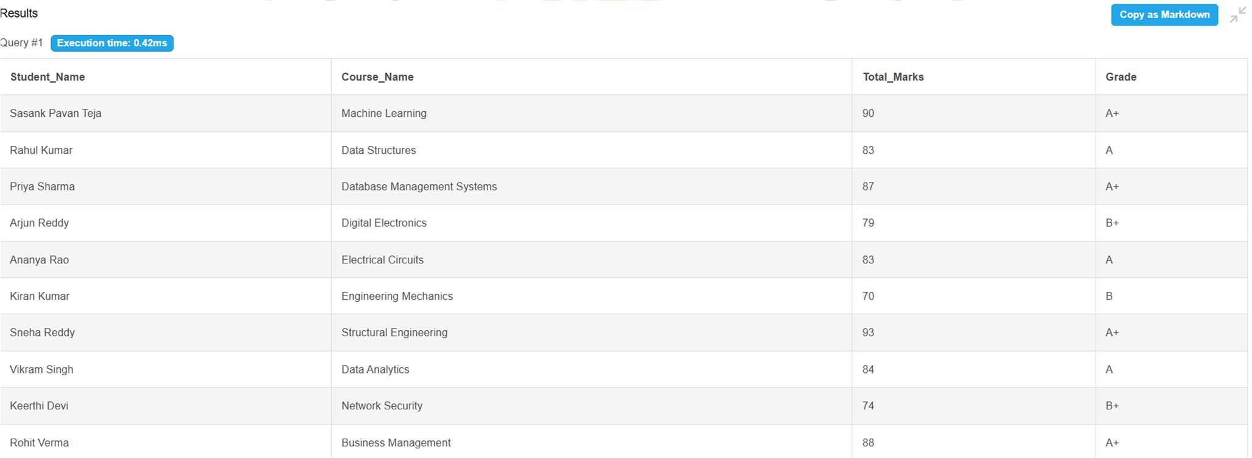
Q16. Students per department
SELECT Department_ID, COUNT(*) AS Student_Count FROM Student GROUP BY Department_ID;

Output:

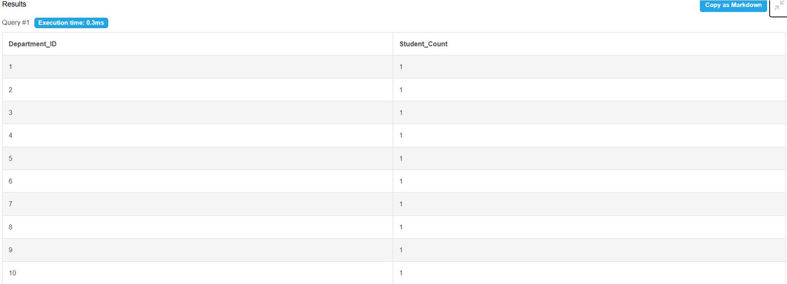

Q17. Courses per department
SELECT Department_ID, COUNT(*) AS Course_Count FROM Course GROUP BY Department_ID;

Output:
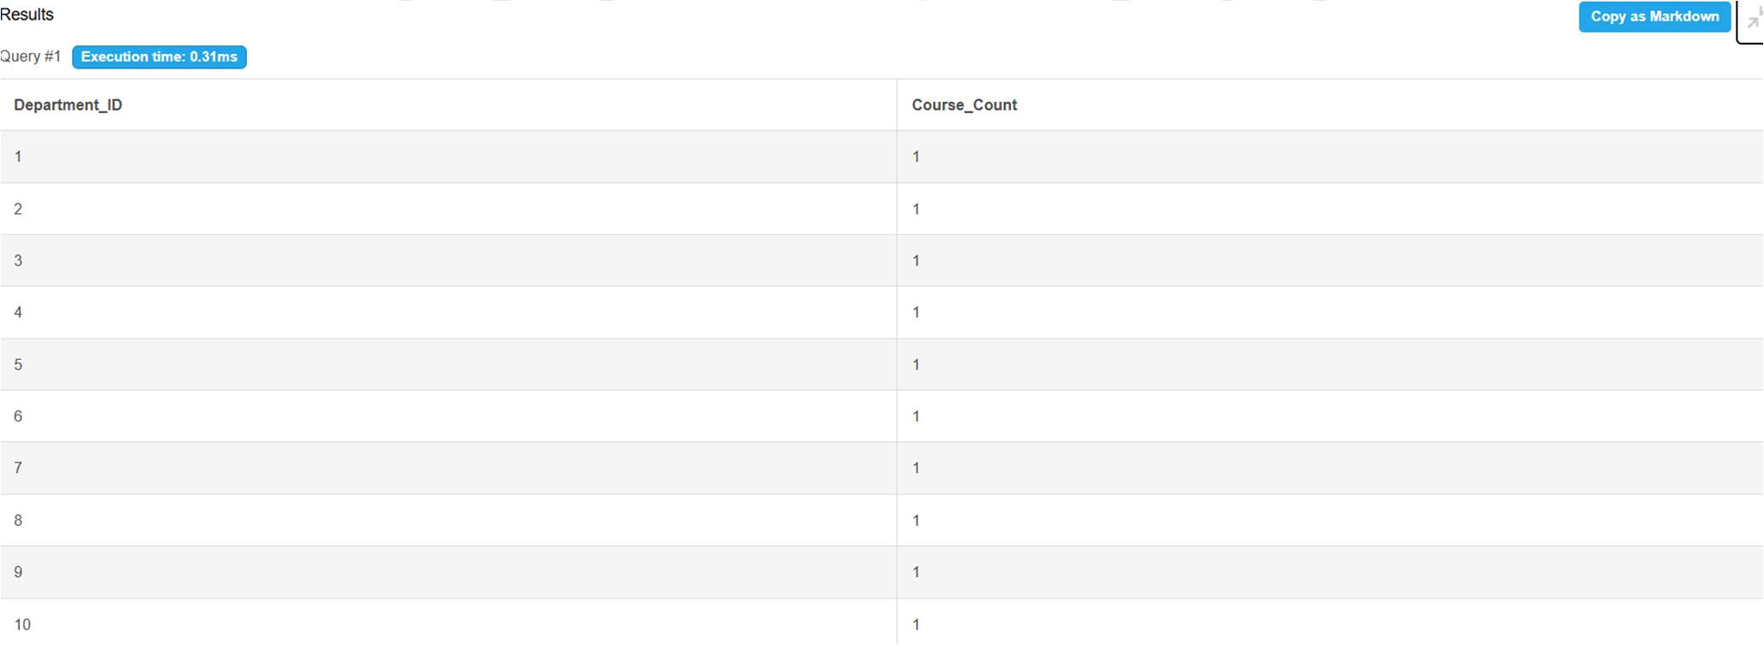

Q18. Average course credits
SELECT AVG(Credits) AS Avg_Credits FROM Course;

Output:

Q19. Maximum total marks
SELECT MAX(Total_Marks) AS Max_Marks FROM Result;

Output:

Q20. Minimum total marks
SELECT MIN(Total_Marks) AS Min_Marks FROM Result;

Output:

Q21. Average total marks
SELECT AVG(Total_Marks) AS Avg_Marks FROM Result;

Output:
Q22. Count passed results
SELECT COUNT(*) AS Passed FROM Result WHERE Result_Status='PASS';

Output:
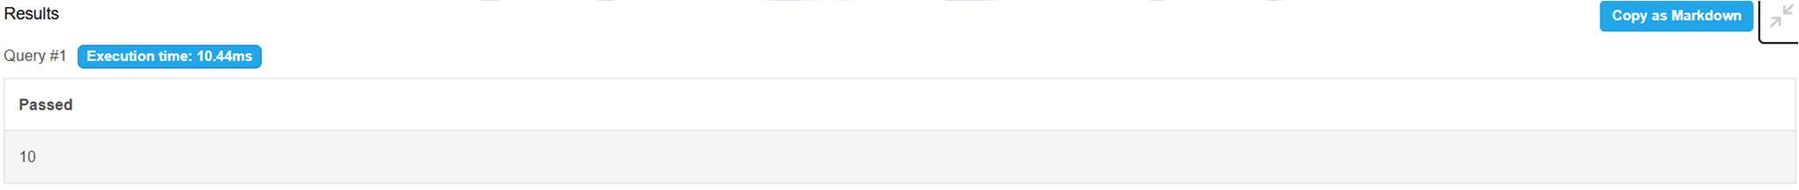

Q23. Count failed results
SELECT COUNT(*) AS Failed FROM Result WHERE Result_Status='FAIL';

Output:
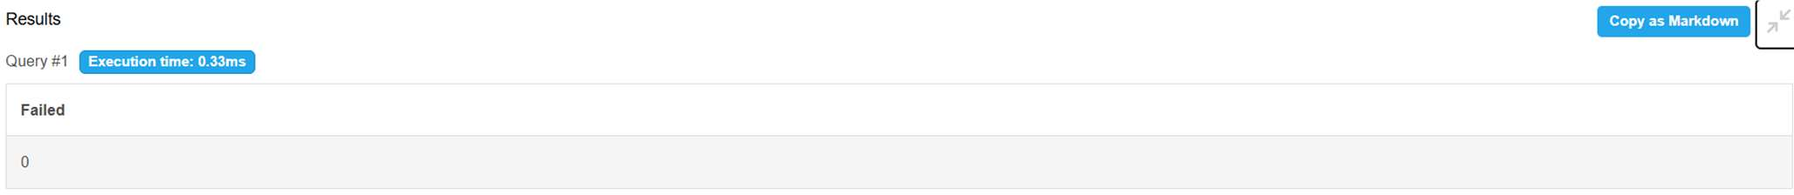

Q24. Students enrolled in DBMS
SELECT s.Student_Name FROM Student s JOIN Enrollment e ON s.Student_ID=e.Student_ID JOIN Course c ON e.Course_ID=c.Course_ID WHERE c.Course_Name='Database Management Systems';

Output:
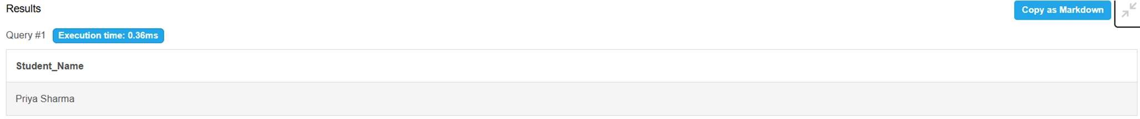

Q25. Faculty teaching IT courses
SELECT DISTINCT f.Faculty_Name FROM Faculty f JOIN Course c ON f.Faculty_ID=c.Faculty_ID JOIN Department d ON c.Department_ID=d.Department_ID WHERE d.Department_Code='IT';

Output:

Q26. Departments having more than 5 students
SELECT Department_ID, COUNT(*) AS Cnt FROM Student GROUP BY Department_ID HAVING COUNT(*) > 5;

Output:

Q27. Courses with 4 credits
SELECT Course_Name FROM Course WHERE Credits=4;

Output:

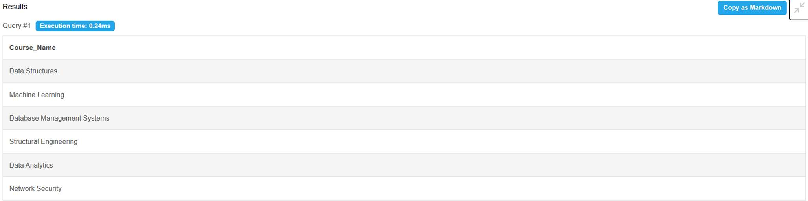

Q28. Students whose names start with A
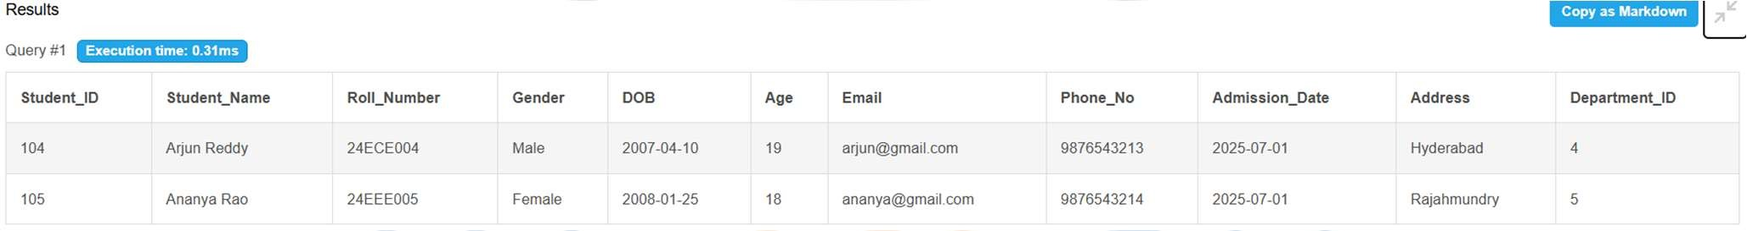
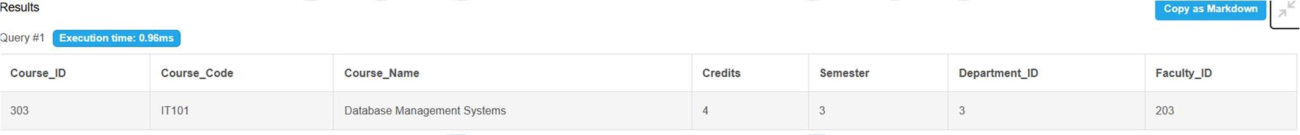
SELECT * FROM Student WHERE Student_Name LIKE 'A%';
Output:
Q29. Search course by keyword
SELECT * FROM Course WHERE UPPER(Course_Name) LIKE '%DATABASE%';
Output:
Q30. Students without department
SELECT * FROM Student WHERE Department_ID IS NULL;

Output:

CONCLUSION
The University Academic Management Database Application provides a structured relational database solution for managing core academic information. The design organizes departments, students, faculty, courses, enrollments, and results into related relations and applies primary keys, foreign keys, uniqueness rules, NOT NULL conditions, and CHECK constraints to support data integrity. The normalization process up to 3NF reduces redundancy and update anomalies. The SQL implementation and query set demonstrate how the database can support insertion, modification, retrieval, aggregation, and academic reporting. The project therefore provides a suitable DBMS cornerstone implementation that can be extended into a complete academic information system.

FUTURE ENHANCEMENTS
- Role-based access for administrators, faculty, and other authorized users.
- Attendance and leave management.
- Fee and scholarship management.
- Timetable and classroom allocation.
- Automated report and analytics dashboards.
- Backup, recovery, audit logging, and stronger database security.

REFERENCES
- Korth, H. F., Silberschatz, A., and Sudarshan, S., Database System Concepts, McGraw Hill.
- Elmasri, R. and Navathe, S. B., Fundamentals of Database Systems, Pearson.

